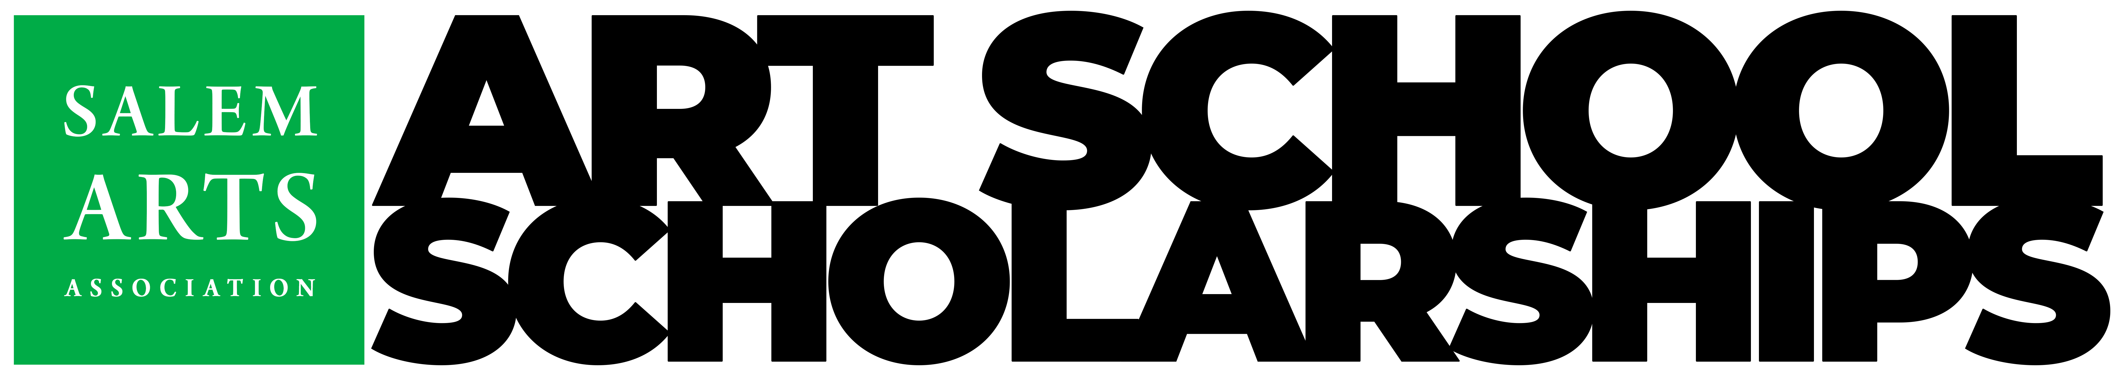
$3000 in Awards from Salem Arts Association
Salem Arts Scholarships are awarded each spring to graduates pursuing the arts through a university program or accredited art school.
Three Scholarship awards will be offered in 2022
- NEW – Creative Collective Innovation Award: Award of $1000 to a graduate from any Northshore school who demonstrates creative innovation in visual arts, performance, and multi-media.
- Ellen Hardy Memorial Scholarship: Award of $1000 to a graduate from any Salem school, or a student member of the Salem Arts Association working in any visual art, performance, and multi-media.
- Paula Beaulieu Art Scholarship: Award of $1000 to a Salem High School class of 2022 graduate working in the visual arts.
This form is used to apply for any Salem Arts Association Scholarship. Applicants do not apply for a specific scholarship. Our Scholarship committee will review all scholarship applications and award based on eligibility and other criteria.
Application process:
- Please complete the application form and provide the required information.
  - Editable forms are available on our website at https://salemarts.org/scholarship
- A personal artist statement and 5 samples (JPG images or media files) representing your creative work are required with the scholarship application.
- Recommendations from your teachers are acceptable but not necessary.
- Apply online, via email, or postal service.
- Applications Due Sunday May 1, 2022

Apply Online
Visit our website at https://salemarts.org/scholarship to fill out the online form and upload images of artworks and other attachments.
Apply via email:
Email your application to scholarship@SalemArts.org. Please include all required files as attachments to your email:
Apply using Mail:
Mail your application and images to:
Salem Arts Association
Art Scholarships
159 Derby Street
Salem MA 01970

Creative Collective Innovation Award
The Innovation Award is sponsored by Salem Arts Association, and provided by Creative Collective. Creative Collective was created to support the critically important intersection of economic development and the creative workforce. It is a community of makers, artisans, creators, small businesses, and economic development strategists. The Collective fosters growth, sustainability, and scalability for small businesses, creative thinkers, organizations, entrepreneurs, and innovators.
Be Bold! This award encourages inclusive innovation in any creative efforts and celebrates student achievements that take their talent to new places through interdisciplinary work, collaborations, breaking systemic boundaries, and creating outcomes beyond the traditional.
Award Purpose and Eligibility:
The Creative Collective Innovation Award will offer one scholarship of $1000 each spring to a senior-year student attending any Massachusetts Northshore school (public, charter, or private), and is pursuing visual arts education either through a university program or through an art school in the fall following their graduation. visual arts, graphic design, performing arts, film, music, acting, Writing or other areas of creative expression will be considered.

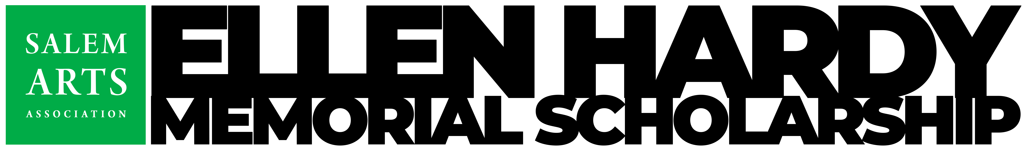
Ellen Hardy Memorial Scholarship Award
Ellen Gibson Hardy (May 18, 1952 - June 18, 2017)
An artist at heart, Ellen forged a career in the Art, Graphic Design, and Publishing world. She founded her own company, Hardy House, which was a full-service Art and Design business of which she was the proprietor for over 19-years working with the likes of MIT, Harvard, Yale, and many other educational and professional organizations. During the years as president of Hardy House she began to exhibit her own artwork at galleries throughout New England and taught Graphic Arts at the Cambridge Adult Center for Education and at Phillips Academy where she also served as Director of Publications for over 14 years.
Ellen was a profound influence on the Salem artistic scene through her involvement with the Salem Public Arts Commission, the annual Salem Arts Festival, and Salem Arts Association, which she advocated heavily for. Ellen served for several years as a member and president of Salem Arts Association.
Award Purpose and Eligibility:
The Ellen Hardy Memorial Scholarship will award one scholarship of $1000 each spring to a senior-year student attending any Salem school (public, charter, or private), or a student artist member of the Salem Arts Association, and is pursuing visual arts education either through a university program or through an art school in the fall following their graduation. visual arts, graphic design, performing arts, music, acting, or other areas of creative expression will be considered. Ellen Hardy was a founding member and served as President of the Salem Arts Association through 2015. She was very active in contributing to the Salem Arts Associations success and was also a prolific artist and performer herself. We are honored to offer this scholarship program in her memory.

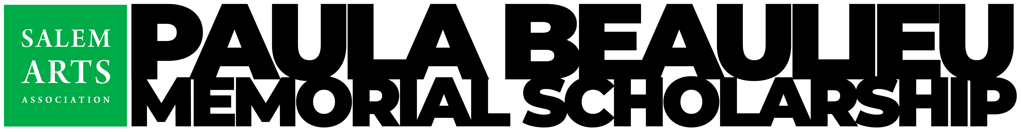
Paula Beaulieu Memorial Scholarship Award
Paula Frances Beaulieu (May 28, 1947 - January 24, 2014)
Paula obtained her B.S. degree from Lowell State University before obtaining her M.S. in Arts & Education at Florida Atlantic University. Her career included teaching grades 2 and 5 at Pearl St. School in Reading, Mass., author of children’s educational books, counselor and educational toy developer to name a few. Most notably, Paula was an art educator, running her own business teaching people of all ages to “Connect with Their Creativity” for over 15 years. Paula was an artist throughout her life, a legacy she brought forward from her mother Rita Casey.
After growing up in Methuen, Mass., Paula resided in Hollywood, Florida and Reading, Mass. (where she raised her two sons Dan and Matt) before moving to Salem, Mass., where she spent her remaining years. “Creativity occurs in the moment, and in the moment we are timeless.”
—The Artist’s Way: A Spiritual Path to Higher Creativity by Julia Cameron
Award Purpose and eligibility:
The Paula Beaulieu Scholarship will award $1000 each spring to a Salem High School Senior who is pursuing visual arts education either through a university program or through an art school in the fall following their graduation. All of the visual arts will be considered. Paula Beaulieu was an active artist in the Salem Arts Association and taught young and old alike through her program “Connect with Their Creativity.” Her family has chosen Salem Arts Association and Salem High School as beneficiaries of any donations made in her honor.

Application Form

Student Information:
Name: _________________________________________________________________
Address: _______________________________________________________________
Telephone: _____________________________________________________________
Email: ________________________________________________________________
High School: ____________________________________________________________

Parents or Guardians Information:
Parent/Guardian One Name: _______________________________________________
Parent/Guardian One Occupation: ______________________ [ ] Full-time [ ] Part-time
Parent/Guardian Two Name: _______________________________________________
Parent/Guardian Two Occupation: ______________________ [ ] Full-time [ ] Part-time
Preferred Telephone: _____________________________________________________
Email: ________________________________________________________________
Number of Siblings: _____________________________________________________
Number of Siblings in College or Trade School: _______________________________
Average Yearly Household income: _________________________________________

Educational Institution Attending:
Educational Institution Name: ______________________________________________
Educational Institution Location: ____________________________________________
Have you received an acceptance letter? [ ] Yes [ ] No
Estimated Annual Tuition: _________________________________________________
Expected Family Contribution: ______________________________________________
Expected Personal Contribution: ____________________________________________
Have you filed for Financial Aid? [ ] Yes [ ] No
Have you received any Financial Aid? [ ] Yes [ ] No
If yes, list the total amount of Financial Aid received: __________________________
Have you filed for other scholarships? [ ] Yes [ ] No
Have you already received Scholarship funding? [ ] Yes [ ] No
If yes, list the total amount of Scholarship Funding received: _____________________

How Will You Use This Scholarship?
______________________________________________________________________
______________________________________________________________________
______________________________________________________________________
______________________________________________________________________

What Activities and Organizations Do You Participate In?
______________________________________________________________________
______________________________________________________________________
______________________________________________________________________
Personal Statement: (why are you pursuing art, what do you hope to gain through college, inspirations)
______________________________________________________________________
______________________________________________________________________
______________________________________________________________________
______________________________________________________________________
______________________________________________________________________

Other Notes: ______________________________________________________________________
______________________________________________________________________
______________________________________________________________________
______________________________________________________________________

Reference:
Someone we can speak to about your ability. Please include phone number and email. (optional)
Name: _________________________________________________________________
Telephone: _____________________________________________________________
Email: ________________________________________________________________
Relationship: ___________________________________________________________

Student Signature: _____________________________________Date: ____________

Parent/Guardian Signature: ______________________________Date: ____________

